;reK yd lvS%
d wud;HxYh
.d% óh yd mdi,a lvS% d hI;, myilq ï mj% ¾Ok rdcH wud;HdxYh

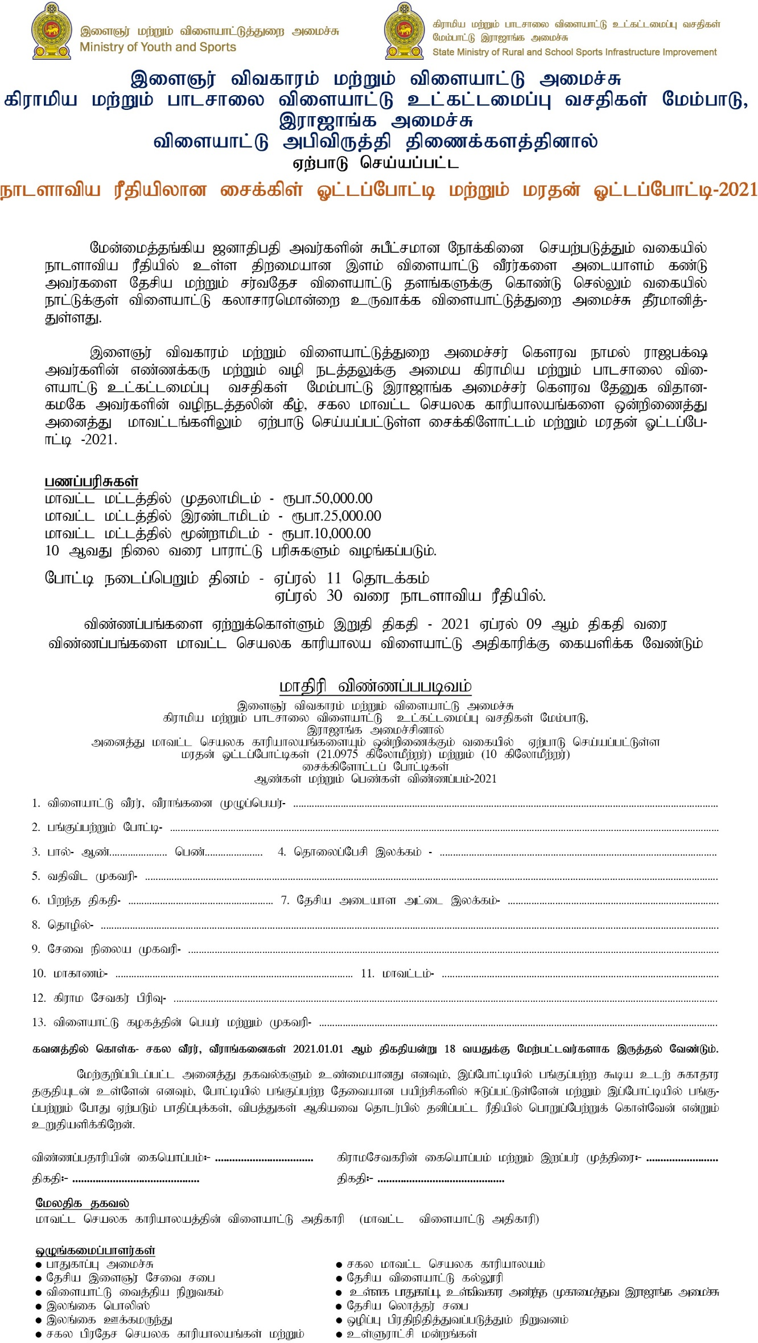

(ehlshtpa ujP

papy; 100 Nghlb;

fs);

